

**Advanced Tools for fighting Online illegal trafficking**

**D1.2 – IPR Plan**

|  |  |
| --- | --- |
| WP number and title | WP1 – Project Management |
| Lead Beneficiary | ENG |
| Contributor(s) | ALL |
| Deliverable type | Report |
| Planned delivery date | 31/10/2018 |
| Last Update | GG/DD/AAAA |
| Dissemination level | CO |

Disclaimer

This document contains material, which is the copyright of certain ANITA contractors, and may not be reproduced or copied without permission. All ANITA consortium partners have agreed to the full publication of this document. The commercial use of any information contained in this document may require a license from the proprietor of that information.

The ANITA Consortium consists of the following partners:

|  |  |  |  |  |
| --- | --- | --- | --- | --- |
| **Participant No** | **Participant organisation name** | **Short Name** | **Type** | **Country** |
| 1 | Engineering Ingegneria Informatica | ENG | IND | IT |
| 2 | Centre for Research and Technology Hellas CERTH - ETHNIKO KENTRO EREVNAS KAI TECHNOLOGIKIS ANAPTYXIS | CERTH | RTO | GR |
| 3 | Centro Ricerche e Studi su Sicurezza e Criminalità | RISSC | RTO | IT |
| 4 | Expert System S.p.A. | EXPSYS | SME | IT |
| 5 | AIT Austrian Institute of Technology GMBH | AIT | RTO | AT |
| 6 | Fundacio Institut de BioEnginyeria de Catalunya | IBEC | RTO | ES |
| 7 | Istituto Italiano per la Privacy | IIP | NPO | IT |
| 8 | SYSTRAN SA | SYSTRAN | SME | FR |
| 9 | Stichting Katholieke Universiteit Brabant | TIU-JADS | RTO | NL |
| 10 | Dutch Institute for Technology, Safety & Security | DITSS | NPO | NL |
| 11 | VIAS Institute | VIAS | RTO | BE |
| ***Law Enforcement Agencies (LEAs)*** | | | | |
| 12 | Provincial Police Headquarters in Gdansk | KWPG | USER | PL |
| 13 | Academy of Criminalistic and Police Studies – Kriminalisticko-Policijska Akademija | AoC | USER | RS |
| 14 | Home Office CAST | CAST | USER | UK |
| 15 | National Police of the Netherlands | NPN | USER | NL |
| 16 | General Directorate Combating Organized Crime, Ministry of Interior | GDCOC | USER | BG |
| 17 | Local Police Voorkempen | LPV | USER | BE |

Document History

|  |  |  |  |  |
| --- | --- | --- | --- | --- |
| **VERSION** | **DATE** | **STATUS** | **AUTHORS, REVIEWER** | **DESCRIPTION** |
| V0.1 | 02/10/2018 | Draft | Youssef BOUALI, ENG | First draft of table of content |
| V0.2 | 19/10/2018 | Draft | Youssef BOUALI, ENG | Deliverable ready for ENG internal review |
| V0.3 | 22/10/2018 | Draft | Ernesto La Mattina, Youssef BOUALI, ENG | Deliverable ready for Consortium internal review |
|  |  |  |  |  |
|  |  |  |  |  |
|  |  |  |  |  |
|  |  |  |  |  |

Definitions, Acronyms and Abbreviations

|  |  |
| --- | --- |
| **ACRONYMS / ABBREVIATIONS** | **DESCRIPTION** |
| CA | Consortium Agreement |
| DESCA | Development of a Simplified Consortium Agreement |
| GA | Grant Agreement |
| IPR | Intellectual Property Rights |
| PMC | Project Management Committee |
| TMC | Technical Management Committee |

Table of Contents

Executive Summary 8

1 Introduction 9

1 Initial Agreements on IPR Management 10

1.1 Protection of Background 10

1.2 Protection of Foreground 10

1.3 Notion of Joint Ownership 10

1.4 Access Rights 11

1.4.1 Access rights for project implementation 11

1.4.2 Access rights for exploitation 11

1.4.3 Specific Provisions for Access Rights to Software 11

1.4.4 Financial conditions for Access Rights 12

1.5 Dissemination Constraints 12

1.6 Confidentiality and Non-Disclosure 12

2 ANITA Exploitable Background and Foreground 14

2.1 Exploitable background 14

2.2 Partners’ expected involvement and contributions 17

2.3 ANITA expected exploitable foreground 18

3 Dissemination of Foreground 19

3.1 Dissemination of own results 19

3.2 Dissemination of another partner’s unpublished Results or Background 20

3.3 Cooperation obligations 20

3.4 Use of names, logos or trademarks 20

4 IPR Management & Issue Handling 21

4.1 IPR management bodies 21

4.2 IPR issue handling 21

5 Conclusions 23

6 References 24

List of Figures

Figure 1: ANITA IPR-related process for dissemination 19

Figure 2: IPR issue handling process in ANITA 22

List of Tables

Table 1: List of Partners' Background for ANITA 17

Table 2: ANITA Partners' Involvement and Contributions 18

Table 3: ANITA Expected Exploitable Results 18

# Executive Summary

Intellectual property (IP) is an asset that a person or organization can own, sell, license, or even give away at pleasure. Unlike other assets however, IP is mostly intangible and its distinct types, namely — patents, designs, trademarks, and copyrights — are assets that are borne from people’s creativity and innovation, and the specific geographical locations concerned. However, the lack of physical parameters by which most of these assets can be defined or identified does not preclude the recognition of their innate value and the need to protect them from theft or unauthorized use, just like tangible assets.

Protection of intellectual property rights (IPRs) stimulates further creativity and innovation, which in turn spur progress in industries and ultimately lead to national development.

ANITA will produce a range of IP types, involving reports and publications, software as well as data. The dissemination and sustainability strategy will ensure a wide dissemination and availability of any project results, by defining and assessing the licensing implications of any used background (e.g. software libraries), allowing the early consideration of such aspects in project-related decisions and design choices, and will also define the licensing models for individual project outcomes together with the general sustainability strategy. To this end, this deliverable will be aligned with and complement the dissemination plan (defined in D11.2) and will constitute a major input to the exploitation strategy (defined in D11.10 and D11.11).

In addition, besides the issues concerning IPR, it includes a discussion of the intended licensing schemes for specific background and foreground artifacts, namely, reports, software, and datasets. Finally, this deliverable also presents general policies regarding the knowledge dissemination activities which aim at making project foreground as accessible and published as possible.

# Introduction

The main purpose of this deliverable is to provide the consortium of ANITA project with the guidelines to potential pitfalls and issues relating to IPR that may encounter during the lifetime of the ANITA project.

This document should be considered in conjunction with the **Consortium Agreement *(CA)*** and the **Grant Agreement *(GA)*** signed by each ANITA partner. As stated in the Consortium Agreement, and to the extent that any provision of this deliverable that conflicts with the provisions of the Grant Agreement, the terms and conditions of the Grant Agreement shall prevail. Moreover, if any provision of this deliverable conflicts with the provisions of the Consortium Agreement, the terms and conditions of the Consortium Agreement shall prevail.

The ANITA partners are requested (as they have committed themselves) to communicate any IPR issues that may arise during the lifetime of the project. This communication shall be targeted to the Project Coordinator and the member of the Executive Board.

# Initial Agreements on IPR Management

This chapter describes the way Intellectual Property Rights are handled in ANITA project. It summarizes the general IPR agreement, which is a part of the Consortium Agreement of the project. It presents the current plans for the intellectual property rights (IPR) management which aim at ensuring the wide accessibility and availability of all outcomes produced by the project.

## Protection of Background

Background IPR means all Intellectual Property Rights owned by or licensed to ANITA Consortium at the start of the Project. It is also important to define IPR, which is:

“Intellectual Property Rights” or “IPR” means all industrial and intellectual property rights including patents, utility models, rights in inventions, registered designs, rights in designs, trademarks, copyright and neighbouring rights, database rights, moral rights, trade secrets, and rights in confidential information and know-how (all whether registered or unregistered and including any renewals and extensions thereof) and all rights or forms of protection having equivalent or similar effect to any of these which may subsist anywhere in the world and applications for registrations of any of the foregoing;

|  |
| --- |
| In the Consortium Agreement, partners have identified and agreed on the background for the project and have also informed where relevant that access to specific background is subject to legal restrictions or limits as specified in section 2.1. |
| A partner may add further own background during the project by written notice to the other partners, and this case approval of the General Assembly is needed. |

## Protection of Foreground

Foreground means the tangible and intangible results which are generated within ANITA project duration, including pieces of information, materials and knowledge and whether or not they can be protected. It includes intellectual property rights (e.g. copyrights, industrial designs, patents, plant variety rights), similar forms of protection (e.g. rights for databases) and unprotected know-how (e.g. confidential material). Results generated outside the project are not foreground.

|  |
| --- |
| The Foreground resulting from the project is owned by the participant(s) generating it. |

## Notion of Joint Ownership

It is important to note that: **Results (Foreground) are owned by the partner that generates them.**

In situation where several partners have jointly generated results and where their respective contribution to the results cannot be ascertained or where it is not possible to separate them for the purpose of applying for, obtaining or maintaining their protection, they shall, unless otherwise agreed in writing, have **joint ownership** of such results.

In addition, unless otherwise agreed between joint owners, i) each of the joint owners shall be entitled to use their jointly owned results for non-commercial research activities on a **royalty-free basis**, and without requiring the prior consent of the other joint owner(s), and ii) each of the joint owners shall be entitled to otherwise exploit the jointly owned Results and to grant non-exclusive licenses to third parties (without any right to sub-license) behind prior **notice of 45 calendar days** and **fair and reasonable compensation**.

|  |
| --- |
| Jointly generated results have joint ownership. |
| Joint owners may USE their jointly owned results for non-commercial research activities on a royalty-free basis. |
| Joint owners may EXPLOIT their jointly owned results and to grant non-exclusive licenses to third parties behind prior notice of 45 calendar days and fair and reasonable compensation. |

## Access Rights

### Access rights for project implementation

Each partner shall implement its tasks in accordance with the Consortium Plan and shall bear sole responsibility for ensuring that its acts within the project do not knowingly infringe third party property rights. Any access rights granted expressly **exclude** any rights to sublicense unless expressly stated otherwise. Access rights for project implementation **shall be free** of any administrative transfer costs, and are granted on a non-exclusive basis.

### Access rights for exploitation

Access rights to ANITA results for exploitation of a partner’s own results shall be granted on **fair and reasonable conditions**. Also, access rights to background if needed for exploitation, including for research on behalf of a third party, shall be granted on fair and reasonable conditions. A request for access rights may be made up to 12 months after the end of the project.

Access rights to results for internal research activities shall be granted on a **royalty-free basis**.

### Specific Provisions for Access Rights to Software

Partners’ access rights to software **do not** include any right to receive Source Code or object code ported to a certain hardware platform or any right to receive Source Code, Object Code or respective Software Documentation in any particular form or detail, but only as available from the partner granting the access rights.

Access rights to a foreground software shall comprise: i) access to the object code; and, where normal use of such an object code requires an Application Programming Interface (API), access comprises the object code and such an API; and, ii) if a partner can show that the execution of its tasks under the project or the exploitation of its own results is technically or legally impossible without access to the source code, then access to the source code is granted to the extent necessary.

Background shall only be provided in object code unless otherwise agreed between the partners concerned.

|  |
| --- |
| Access rights to a foreground software shall comprise:   * access to the object code, and/or * access to APIs |
| Access rights to a background software shall comprise:   * only to object code |

### Financial conditions for Access Rights

|  |  |  |  |
| --- | --- | --- | --- |
| **Purpose** | **Access right to Background** | **Access right to Foreground** | **Timing** (to request access rights) |
| ***Needed* for the implementation of the project activities** | **Royalty-free** | **Royalty-free** | Until the end of the project |
| **Needed for Exploitation** | **Fair and reasonable conditions**  **+**  **Separate written license agreement** | **Fair and reasonable conditions** | Until **12 months** after the end of the project or the termination of  the participant  concerned |

## Dissemination Constraints

Each partner must ensure that the foreground it owns is disseminated as swiftly as possible. However, any dissemination (including publications or on web-pages) should be delayed until a decision about its possible protection has been made (through IPR or trade secrets). The other participants may object to the dissemination activity if their legitimate interests in relation to their foreground or background could suffer disproportionately great harm.

Dissemination can be seen as the means (i.e. press releases, conferences, scientific publications, exhibitions, workshops, newsletters, websites, etc.) through which research results are presented to the public.

It is important to notice that official publications in the course of a protection right application (e.g. the compulsory publication of a patent application after its filing) are not considered dissemination. The target of the dissemination may be the general public or a specific group of professionals in a determined sector.

## Confidentiality and Non-Disclosure

Where dissemination of foreground does not adversely affect its protection and use, there is an obligation to disseminate it swiftly. However, no dissemination of confidential material may take place before a decision is made regarding its possible protection. Indeed, any disclosure, even to a single person who is not bound by secrecy or confidentiality obligations (typically someone from a different organisation outside the consortium), prior to filing for protection, can be considered as constituting a disclosure detrimental to patentability.

Evidently, no dissemination at all may take place if it is intended to protect the foreground as a trade secret (i.e. confidential know-how). Confidentiality obligations are also detailed in the ANITA CA.

|  |
| --- |
| Any data which is to remain secret should be clearly labelled as confidential and appropriate measures should then be taken by the other partners and the Commission to maintain confidentiality, even after the end of the project. |

The recipients of confidential information must undertake in addition and without prejudice to any commitment on non-disclosure under the Grant Agreement, for a period of **4 years** after the end of the Project:

|  |
| --- |
| 1. Not to use confidential information otherwise than for the purpose for which it was disclosed; |
| 1. Not to disclose confidential information without the prior written consent by the Disclosing Party; |
| 1. To ensure that internal distribution of confidential information by a recipient shall take place on a strict need-to-know basis; and |
| 1. To return to the disclosing partner, or destroy, on request all confidential information that has been disclosed to the recipients including all copies thereof and to delete all information stored in a machine readable form to the extent practically possible. |

# ANITA Exploitable Background and Foreground

## Exploitable background

|  |  |  |  |  |  |  |
| --- | --- | --- | --- | --- | --- | --- |
| # | **Background Name** | **Background Description** | **Owner** | **license** | **Conditions / Limitations for implementation in ANITA** | **Conditions / Limitations for exploitation** |
| **1** | **Resource Analysis Framework (RAF)** | Framework for integration and orchestration of Natural Language Processing techniques in order to classify resource, extract relevant information, perform Named Entity Recognition, language recognition, entity extraction, lemmatisation, tagging suggestion, text summarisation, pattern recognition, sentiment analysis, emotion recognition. | ENG |  | Access Rights to ENGINEERING INGEGNERIA INFORMATICA SPA background is only granted for the purpose of ANITA project activities as defined in the workplan. NO Access Rights to source code nor object code will be granted by ENGINEERING INGEGNERIA INFORMATICA SPA. | Usage and Exploitation restricted and conditioned to commercial license agreement. Prior to exploitation involving any of the stated background, consent must be obtained from ENGINEERING INGEGNERIA INFORMATICA SPA. |
| **2** | **Source Integration Framework (SIF)** | Framework for searching information sources, configuring crawling processes, scheduling resources extraction services. | ENG |  | Access Rights to ENGINEERING INGEGNERIA INFORMATICA SPA background is only granted for the purpose of ANITA project activities as defined in the workplan. NO Access Rights to source code nor object code will be granted by ENGINEERING INGEGNERIA INFORMATICA SPA. | Usage and Exploitation restricted and conditioned to commercial license agreement. Prior to exploitation involving any of the stated background, consent must be obtained from ENGINEERING INGEGNERIA INFORMATICA SPA. |
| **3** | **Graph based Knowledge Base Management** | Graph based infrastructure for representing domain knowledge and relevant information and software services for managing and browsing graph nodes and relationships. | ENG |  | Access Rights to ENGINEERING INGEGNERIA INFORMATICA SPA background is only granted for the purpose of ANITA project activities as defined in the workplan. NO Access Rights to source code nor object code will be granted by ENGINEERING INGEGNERIA INFORMATICA SPA. | Usage and Exploitation restricted and conditioned to commercial license agreement. Prior to exploitation involving any of the stated background, consent must be obtained from ENGINEERING INGEGNERIA INFORMATICA SPA. |
| **4** | **Chain of custody management module** | Services for managing the chain of custody taking into account data protection, legal and privacy requirements | ENG |  | Access Rights to ENGINEERING INGEGNERIA INFORMATICA SPA background is only granted for the purpose of ANITA project activities as defined in the workplan. NO Access Rights to source code nor object code will be granted by ENGINEERING INGEGNERIA INFORMATICA SPA. | Usage and Exploitation restricted and conditioned to commercial license agreement. Prior to exploitation involving any of the stated background, consent must be obtained from ENGINEERING INGEGNERIA INFORMATICA SPA. |
| **5** | **Investigative Hypothesis management** | Smart widget for assisting forensics analysts to formulate investigative hypothesis providing interactive and user-friendly user interface. | ENG |  | Access Rights to ENGINEERING INGEGNERIA INFORMATICA SPA background is only granted for the purpose of ANITA project activities as defined in the workplan. NO Access Rights to source code nor object code will be granted by ENGINEERING INGEGNERIA INFORMATICA SPA. | Usage and Exploitation restricted and conditioned to commercial license agreement. Prior to exploitation involving any of the stated background, consent must be obtained from ENGINEERING INGEGNERIA INFORMATICA SPA. |
| **6** | **Image and video analysis module** | Module that extracts relevant information from the visual content (images, videos) available online. It automatically detects a wide set of meaningful semantic entities (objects, concepts, events) in the available visual content. | CERTH |  | Access Rights to CERTH’s Background is only granted to the extent that is needed for the implementation of the action, being agreed that no Access Rights to source code nor object code will be granted by CERTH. CERTH may freely use them in the Project or in any other collaborative R&D project. All Background IP rights included is subject to the terms described in this Consortium Agreement and cannot be used for commercial purposes or any other economic purposes without the prior authorization of CERTH. | CERTH’s Background is not Needed by the other Parties for Exploitation of their own Results thus no Access Rights will be granted by CERTH for Exploitation, unless otherwise agreed between the Parties concerned. Considering this, the specific limitations (including third party rights) are not listed in this Attachment. Access Rights to Background is only granted to the extent that said Background is not subject to terms and conditions in existing third party agreements that may prohibit grant of Access Rights in the Project |
| **7** | **Visual indexing module** | The visual indexing module enables large-scale indexing of images and videos, using global as well as local information, so as to realize fast and accurate search and retrieval tasks in vast visual content collections. | CERTH |  |
| **8** | **Cogito Technology** |  | EXPSYS |  | If the proposed solution will use our semantic engine and / or our Cogito technology API this remain property and exclusivity of ES. It will be made available for the project with free and temporary license for use within the ANITA project only, not to be passed outside. | The use of technology Cogito will be governed by specific trade agreements and licenses with partners who intend to adopt it. Access to Cogito Technology will require legal consent of the company and discussion of possible financial terms or copyright terms. |
| **9** |  | SAAS access to existing cloud services about surface, deep and dark web, as well as Blockchain information. | AIT |  | Quantity of data to be treated to be defined according to the project needs. | Bilateral SAAS agreement. |
| **10** | **Access to the product portfolio of SYSTRAN** | SYSTRAN Enterprise Server 8 or 9 and needed translation engines to be defined in specifications | SYSTRAN |  | SYSTRAN's solutions catalog will be made available with no limitation for use within the ANITA project only, as long as agreed eventual new developments for the purpose of the project. No Access Rights to source code nor object code will be granted by SYSTRAN SAS. | Usage restricted and conditionned to commercial license agreement |
| **11** | **Speech to Text** | SYSTRAN librairies or modules for Speech to Text | SYSTRAN |  | SYSTRAN's solutions catalog will be made available with no limitation for use within the ANITA project only, as long as agreed eventual new developments for the purpose of the project. No Access Rights to source code nor object code will be granted by SYSTRAN SAS. | Usage restricted and conditionned to commercial license agreement |

Table 1: List of Partners' Background for ANITA

## Partners’ expected involvement and contributions

|  |  |
| --- | --- |
| **Partner** | **Expected activities and contributions to project results** |
| ENG |  |
| CERTH |  |
| RISSC |  |
| EXPSYS |  |
| AIT |  |
| IBEC |  |
| IIP |  |
| SYSTRAN |  |
| TIU-JADS |  |
| DITSS |  |
| ISBR |  |
| KWPG |  |
| AoC |  |
| CAST |  |
| NPN |  |
| GDCOC |  |
| LPV |  |

Table 2: ANITA Partners' Involvement and Contributions

## ANITA expected exploitable foreground

|  |  |  |  |  |  |
| --- | --- | --- | --- | --- | --- |
| **Expected Foreground Name** | **Foreground Description** | **Owner/s** | **license** | **Conditions / Limitations for exploitation** | **Linked Background  (if no link write NEW)** |
|  |  |  |  |  |  |
|  |  |  |  |  |  |

Table 3: ANITA Expected Exploitable Results

# Dissemination of Foreground

## Dissemination of own results

During the project and for a period of **1 year** after the end of the project, the dissemination of own Results by one or several partners, shall be governed by the procedure of Article 29.1 of the Grant Agreement. In particular, prior notice of any planned publication shall be given to the other participants at least **45 calendar days** before the publication.

Any objection to the planned publication shall be made in accordance with the Grant Agreement in writing to the coordinator and to the participant(s) proposing the dissemination within **30 calendar days** after receipt of the notice. If no objection is made within the time limit stated above, the publication is permitted.

An objection is justified if:

|  |
| --- |
| 1. the objecting participant’s legitimate academic or commercial interests are compromised by the publication; or |
| 1. the protection of the objecting participant’s foreground or background is adversely affected. |

The objection has to include a precise request for necessary modifications. If an objection has been raised the involved partners shall discuss how to overcome the justified grounds for the objection on a timely basis (for example by amendment to the planned publication and/or by protecting information before publication) and the objecting partner shall not unreasonably continue the opposition if appropriate measures are taken following the discussion.

The objecting partner can request a publication delay of not more than **90 calendar days** from the time it raises such an objection. After **90 calendar days** the publication is permitted provided that confidential Information, background or results of the objecting partners has been removed from the publication.

to sum up, the following Figure 1 illustrates step-by-step ANITA IPR-related process for dissemination:

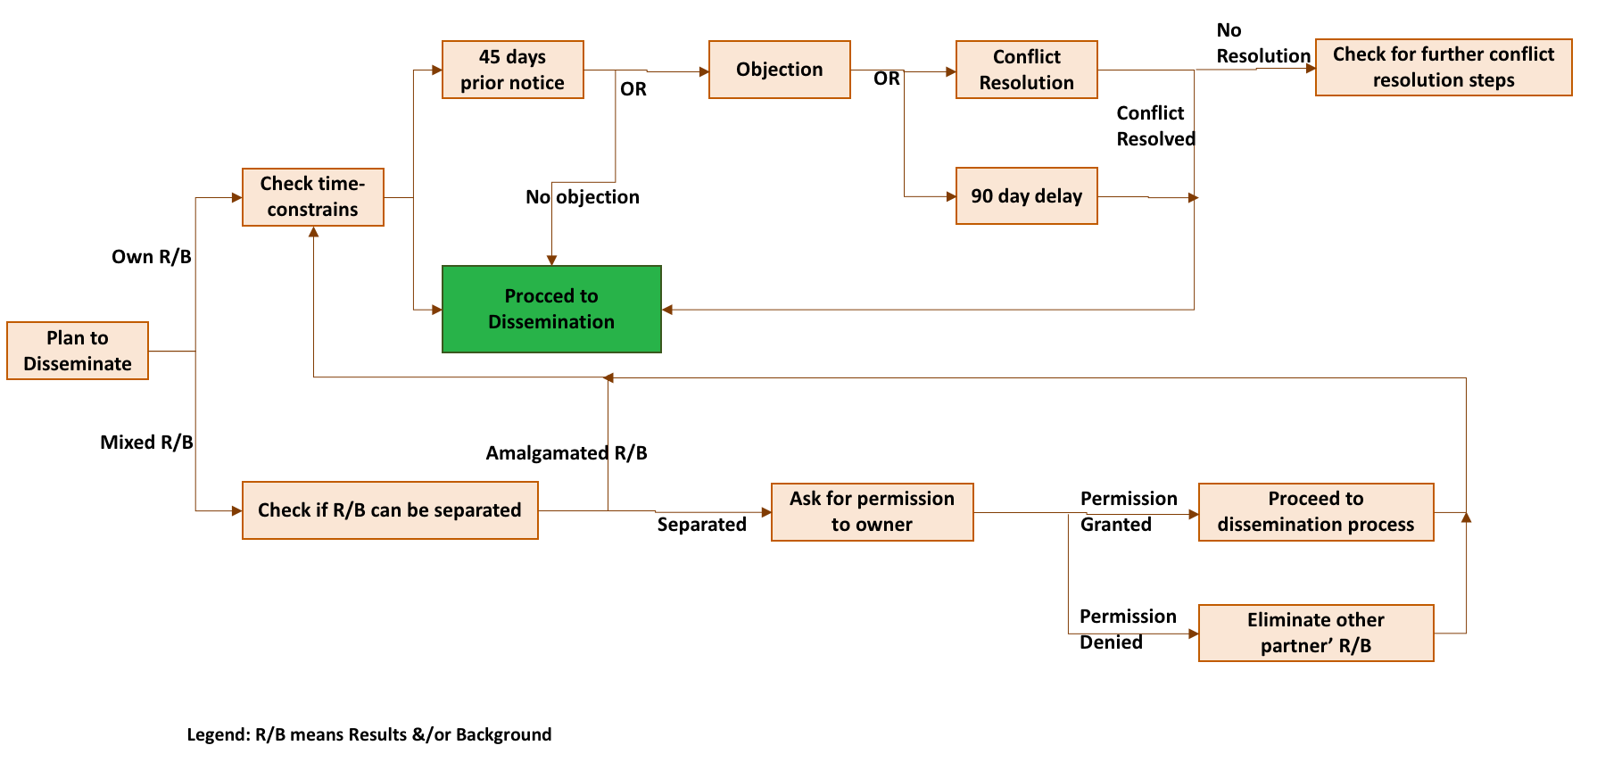

Figure 1: ANITA IPR-related process for dissemination

## Dissemination of another partner’s unpublished Results or Background

Any partner shall not include in any dissemination activity another partner's results or background without obtaining the owner’ prior written approval, unless they are already published.

The mere absence of an objection is not to be interpreted as an approval. In case the results and/or background are amalgamated in such a way that the ownership of these results and/or background cannot be ascertained, the publishing partner shall include this information obligations as specified in 3.1.

|  |
| --- |
| Thus, participants cannot publish foreground or background of another partner, even if such foreground or background is amalgamated with the partner’s foreground, without the other participant’s prior written approval. |

## Cooperation obligations

The partners must cooperate to allow the timely submission, examination, publication and defence of any dissertation or thesis for a degree that includes their results or background subject to the confidentiality and publication provisions agreed in this Consortium Agreement.

## Use of names, logos or trademarks

**Nothing** in this Consortium Agreement shall be construed as conferring rights to use in advertising, publicity or otherwise the name of the partners or any of their logos or trademarks without their prior written approval.

# IPR Management & Issue Handling

In ANITA, all project partners agreed on explicit rules concerning IP ownership, access rights to any Background and Results for the execution of the project and the protection of intellectual property rights (IPRs) and confidential information before the project starts. Therefore, in order to properly address such issues, the CA (based on DESCA model) between all project partners established a legal framework aimed at providing clear regulations for issues (within the consortium) on the work, IP-Ownership, Access Rights to Background and Results for the duration of the project and any other matters of the consortium’s interest.

## IPR management bodies

1. ***Consortium Agreement:*** Prior to the start of the project, all partners have signed the project “Consortium Agreement” (CA). This document sets out all the internal rules of the project and has been signed by all partners. The CA includes the Conflict Resolution and Relationship breakdown, IPR Management, etc. The General Assembly will control the respect of IPR rules and information dissemination procedures defined in the CA and the present deliverable D1.2 IPR plan. The obligations and rights of the participants are detailed in the Consortium Agreement making explicit reference to decision procedures, risk management strategies, and the right of each partner in the exploitation of results.
2. ***General Assembly*:** is the highest decision-making body of the project. It is responsible for major administrative decisions that require a vote; it is the deciding body on potential disputes and also manages IPR issues. Each partner is represented with one person in the GA, which will be chaired by the Project Coordinator.
3. ***Project Management Committee (PMC)*:** led by the Project Coordinator, is the executive body of the project with tasks including IPR issues handling and conflict resolution. PMC will comprise one representative from each partner, the PC and the STC. The PMC reports to GA.
4. ***Technical Management Committee (TMC)*:** report to the PMC, and has the role to ensuring the timely progress of the project, and the high quality of the results. The TMC is responsible also in IPR issues handling and conflict resolution prior to escalating to the PMC.

## IPR issue handling

When a conflict occurs related to IPR issues, consensus should be sought to solve the problem. If the problem cannot be solved, the partner prepares a description of the problem and its possible solutions, and transmits it to the Technical Management Committee (TMC). If consensus cannot be reached within the TMC, the interested partner escalates it to the Project Management Committee (PMC) and a vote occurs, requiring a simple majority. Ultimately, any unresolved dispute is referred to the GA who, in the event that an amicable agreement cannot be reached within that body, will have the right to appoint external independent arbitrators. The following Figure 2 summarizes the process of IPR issue handling in ANITA:

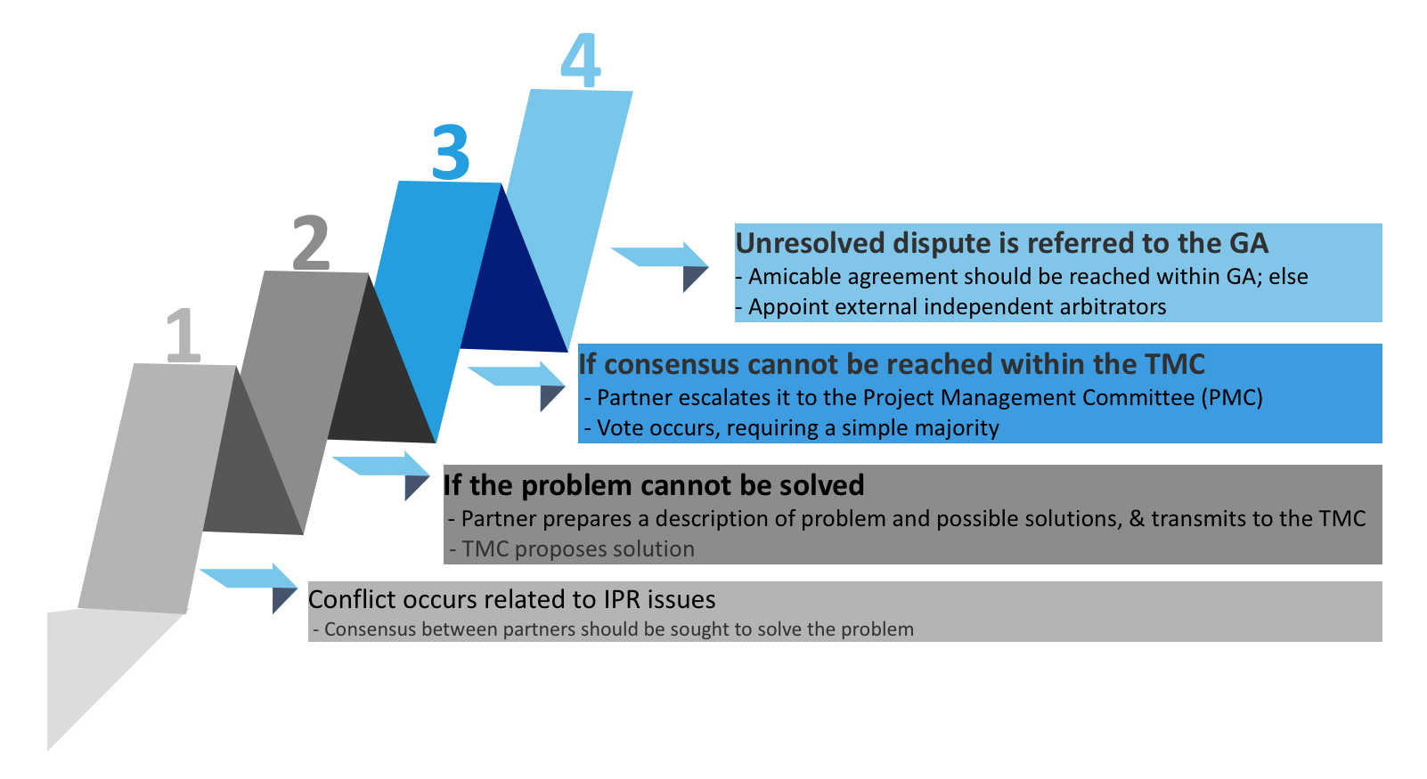

Figure 2: IPR issue handling process in ANITA

# Conclusions

To conclude, ANITA project and its members intend to define and cover well the IPR issues as well as to provide good guidelines for the smooth running of the project. All areas are covered or duplicated in a tangible manner between the different project EC documentation (Consortium Agreement, Grant Agreement, and Description of Work).

As a matter of fact, this deliverable shows the Intellectual Property management in the ANITA project and summarizes the general agreements, which was settled in the Consortium Agreement. For IPR management and handling, ANITA project management bodies have been setup, and addressing the main issues of the IPR management is part of their tasks.

# References

1. ANITA Grant Agreement
2. ANITA Consortium Agreement
3. ANITA Description of Work